No Child Left Inside
@
Threshold Learning Center

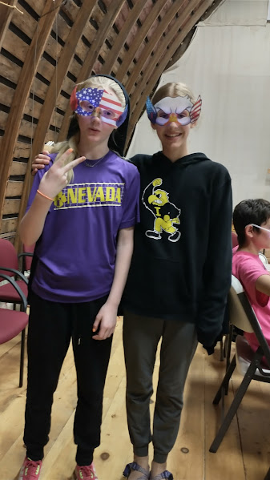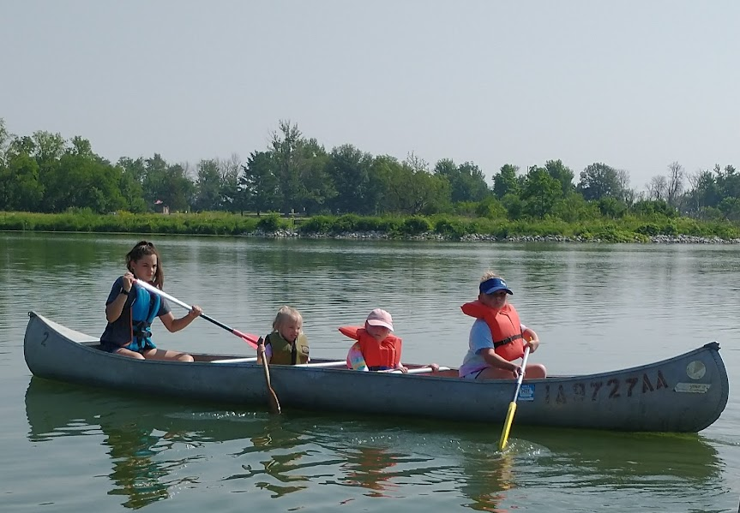

We have a little something for everyone…
2024 SUMMER SCHEDULE

May 31-June 2 Overnight Adventure Camp
June 3-6 Jr. High Chicago Trip
June 10-14 Day Camps – Gardening AM
Building Camp PM
June 15 Fresh Air Concert
June 17-21 Day Camps – TLC 101 AM & PM
June 24-26 Mini Session – AM ONLY – Birding 101
June 26-July 3 Jr./Sr. High New Mexico Trip
July 8-12 Day Camps - Water Wonders AM & PM
July 15-19 Day Camps – AM 1880’s Camp
PM Survival Camp
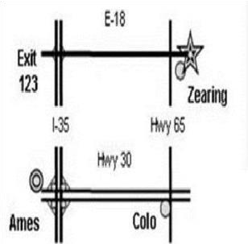
July 22-31 Sr. High Yellowstone/Grand Tetons Trip
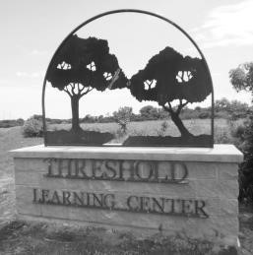

Threshold Learning Center is located one mile east of Hwy. 65
on Hwy. E18 near Zearing, IA.
For more information contact Gretta Reischauer:
nclitlc@gmail.com or 641-487-7455

AFTERNOON CAMPS
MORNING CAMPS

Morning camps meet 9 -11 daily for children entering Afternoon camps meet 1–3pm daily for children entering
K-2nd grades. Price is just $40 for the week. grades 3rd – 6th. Price is just $40 for the week.



JUNE 10-14 GARDENING CAMP JUNE 10-14 BUILDING CAMP Learn what plants need to grow, how to prepare While safely learning some building techniques,
produce, and help in TLC’s community garden. you can help us finish a few projects around TLC.

JUNE 17-21 TLC CAMP 101 JUNE 17-21 TLC CAMP 101
Join us for a week of good old “CAMP” activities! Join us for a week of good old “CAMP” activities!
Hikes, canoeing, archery, crafts, the creek & more. Hikes, canoeing, archery, crafts, the creek &more.

JUNE 24-26 MINI-SESSION: AM Only – Becoming Bird Brains. Open to any curious K-8th grader.


JULY 8-12 WATER WONDERS JULY 8-12 WATER WONDERS
Get as wet as possible each day...and Get as wet as possible each day... and
learn about the importance of water. learn about the importance of water.

JULY 15-19 1880’s CAMP JULY 15-19 SURVIVAL CAMP
LIVE Iowa history. Learn what kids did 150 years ago. Learn techniques on how to survive in the wild&
Chores, school, surviving, entertainment and NO PHONES. put those techniques to the test out in the woods.

REGISTER EARLY!!!
Help us help you! Pre-registering keeps our costs low and allows us to help you with possible car-pooling options.

Name________________________________________________________ Age_____ Phone________________________
Address____ ________________________________________________ Email_____________________________________

Mini Session: _____ ($25) Becoming Bird Brains

Day Camps: _____ ($40) Gardening Camp AM _____ ($40) Building Camp PM ($45 After May 10th)
_____ ($40) TLC Camp 101 AM _____ ($40) TLC Camp 101 PM ($45 After May 10th)
_____ ($40) Water Wonders AM _____ ($40) Water Wonders PM ($45 After May 10th)
_____ ($40) 1880’s/Ia. History AM _____ ($40) Survival Camp PM ($45 After May 10th)

Overnights: _____ ($80) Overnight Adventure _____ ($50) Building Camp _____($50) Survival Camp

Trips: _____ ($250) Jr. High Chicago Trip ($300 After April 1st)


_____ ($650) Jr/Sr High New Mexico _____ $250 Payment Plan Deposit ($800 After April 1st)
_____ ($750) Sr. High Yellowstone/Tetons _____ $250 Payment Plan Deposit ($800 After April 1st)

Total Included: ______ Return form & Payment to: TLC
PO Box 36
Zearing, IA 50278
YOUTH OVERNIGHTS & ADVENTURE TRIPS
A Variety of Get-Aways for Students Ages 10 and Up

Overnight Adventure Building Camp Survival Camp
May 31-June 2 $80/Person June 10-14 $50/Person July 15-19 $50/Person
Students entering grades 5-7 Students grades 7-12 Students grades 7-12
Campfires, tenting, hiking, the creek, Help us with a few projects & Help us with our week of
the woods, games, archery, and an our afternoon Building Camp. afternoon Survival Camp.
awesome River Canoe trip. Stay overnight on Thursday Night. Try to survive Thursday Night!

ROAD TRIP!!!



Jr. High Chicago Trip

June 3-6 $250/Person
This trip is for students entering grades 7th – 9th.
Enjoy the Windy City! Union Station, Willis (Sears) Tower, Lake Michigan, Shedd Aquarium, Adler Planetarium, a Water Taxi ride, Navy Pier, Grant Park, and Soldier Stadium. We’ll also visit some Iowa gems on the way there and back.
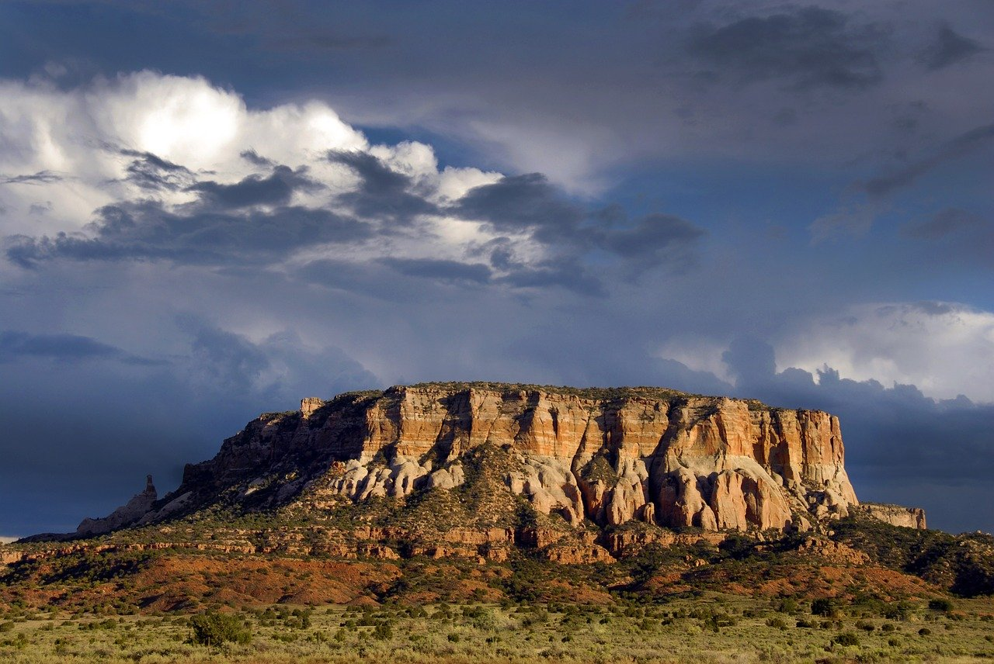

Jr/Sr High New Mexico Trip
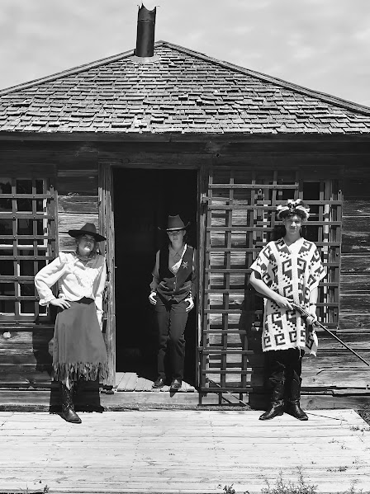

June 26-July 3 $650/Person
This trip is for students entering grades 9th-12th.
Enjoy a train trip out to the great southwest!
Discover New Mexico’s Deserts, Mountains, the
Pecos River Valley, old West and Native American History,
Incredible Art and unique cuisine.
Sr. High Yellowstone/Tetons Trip
July 22-31 $750/Person
Payment plans are available!!! This trip is for students grades 10th-12th.
To get the pre-registration rate, 10 days of wild in a beautiful mountain setting
Registration and Deposits that will take your breath away! See Yellowstone’s
are required by April 1st. geysers, canyons, forest, history & wildlife.

We can only take the first 10 that sign up for our trips, so send your registration in early!

PLAN YOUR OWN EVENTS @ TLC

TLC’s Barn is available to rent for graduations, birthday parties, reunions, weddings, meetings, dances or any get-together you may be having. Let us do the hosting & cleaning and you just enjoy yourself!!! Rooms are also available to rent for overnight lodging. For just $75/night you can get away from it all & enjoy a cozy night’s stay. Check us out on Hipcamp.com

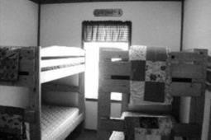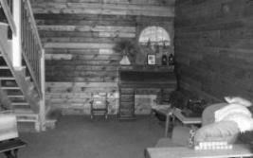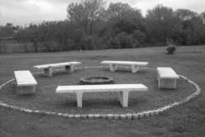

TLC
PO Box 36
Zearing, IA 50278

UPCOMING EVENTS @ TLC

SPRING Work Day April 21, Noon-4pm

Help us get ready for our busy season. We have jobs for any ability: cleaning, gardening, painting, grunt work, and carpentry. Bring the kids, they can help or play. We’ll have Earth Day activities with hikes, games, recycling crafts, and more from 1-4pm.

Conservation Crusaders Club April 21, May 19, June 9, July 14, August 11
We are starting a monthly Club that will meet from 1-5pm on each of the above dates in honor of three of our favorite TLC campers and now board members. These guys have spent one day a month for the last few years walking trails and picking up litter, doing outdoor projects to improve an area, observing and counting wildlife, and just generally making the world a better place for all living things. Of course, another highlight is time with each other in the great outdoors. If you have a Tween or Teen that would think this sounds fun, or is maybe thinking of a job in conservation, have them join us!

FREE Family Gardening Classes April 21, May 19, June 9, July 14, August 11
TLC will be hosting FREE family gardening classes each month from 3:00-6:00pm. As a family we will work in the Community Garden, learn ways to prepare and preserve produce, go for a hike and look for edibles, enjoy a meal, create an item to take home, and read a book. Your family will go home well-fed, with a gift, knowing a little more about vegetables and caring for plants, and feeling a sense of community. Check out our Facebook page for updates on each month’s focus and program.

PRAIRIE PUTT-PUTT Opening Day May 25
This 9-hole course is open Thurs.-Sun. from 11am-7pm. We can also open the course by appt. Mon.-Weds. Cost is just $5/adult, $3/child ages 3-12. The Prairie Mercantile and Snack Shack will also be available during open hours. Proceeds help our after-school Kids Club.

FRESH AIR CONCERT June 15
Join us for our 6th annual Fresh Air Concert featuring a full day of several types of music and entertainment! Enjoy our beautiful outdoor venue for great music and entertainment, great food, and community spirit. Bring a blanket or lawn chair, a picnic, and your favorite drinks. There will be concessions available and various outdoor activities will be going on. You will be helping us provide our programs at an affordable rate with our biggest fundraiser for the year, while enjoying the sounds of local talents.

For more information contact Gretta at nclitlc@gmail.com or 641-487-7455.

